1.Write a c++ program for adding the two numbers?

Program:

using namespace std;

#include<iostream>

main()

{

int a,b;

cout<<"enter a and b values";

cin>>a>>b;

if(int(a) && int(b))

{

cout<<a+b;

}

else

{

cout<<"not valid";

}

}

OUTPUT:

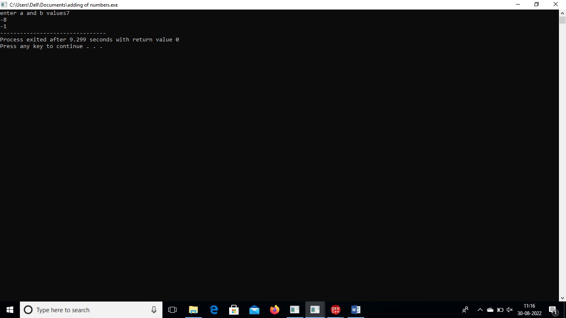

2. Write a c++ program for subtracting of two numbers?

Program:

using namespace std;

#include<iostream>

main()

{

int a,b;

cout<<"enter a and b values";

cin>>a>>b;

if(int(a) && int(b))

{

cout<<a-b;

}

else

{

cout<<"not valid";

}

}

OUTPUT:

